WORKSHOP #7- WASHING MACHINE

# Group 2 Members:

* Natsita - Logic 1 - Flowchart
* Joshua Civello - Logic 1 - Pseudocode
* Seulgi Lee - Logic 2 - Flow Chart
* Md Ridwan Hossain - Logic 2 - Pseudocode
* Luca Novello - Logic 3 - Pseudocode

# Workshop Overview

As you have probably recognized by now, computer systems and applications are all about data. Data is always introduced to the system or application at some point as input. Data input is traditionally accomplished by using a keyboard or mouse, but it is important to be aware there are many other ways to obtain data input. Computer applications can also obtain data input by “pulling” it from some other source (other than a human/end-user). This source can be local (on the same machine) or remote (using the internet). There are many methods available to “pull” data and you will be learning about these in the coming semesters. The most common however, involve files, databases, and web services.

Another widely used method of data input is accomplished using scanners. These are often used in retail stores to scan barcodes for easy data entry. Use of this type of technology is extremely efficient when compared to a manual human method of input – especially if you can use this technology automatically without even human intervention. This workshop is an introduction to using more modern methods of data input and to integrate it into your solutions which ultimately add more efficiencies to daily business processes.

# Workshop Details

A car wash business is looking for a system that will further automate their daily redundancies, more specifically, the processing of customers who line-up for a car wash. To address most of the inefficiencies and costs, the operation has decided to use a fully automated computer kiosk approach (like a drive-thru) which will eliminate the need for a cashier to manually process each customer car wash request and payment.

Regular customers can simply drive up to the kiosk, select a wash option, make a credit card payment (NO CASH), and proceed to get the car washed. The new approach in processing customer transactions has opened an opportunity to offer prepaid monthly memberships that permits up to 3 washes per day for the tier they paid for.

**Note: The process of signing up for VIP membership is not done through the kiosk system and therefore does not have to be defined for this workshop.**

At the time when monthly members create their account (not done using the kiosk), the customer will select the desired wash tier option (see below) they want to sign-up for and are charged accordingly for that selection (this will be their default wash option). Members will have a stick-on barcode chip affixed to their vehicle windshield.

Vehicles approaching the kiosk station are automatically scanned by the system and if a stick-on chip is successfully detected and read, members can be identified including all the details of their membership contract information. Members have the option to override the default wash option they signed up for (applies only to that one wash and does not affect their subscription agreement).

If a member chooses a different wash option from their agreement, regular rates will be charged for the selected wash option (even if it is a less expensive option). You do not have to describe the details of what is printed on the receipt, but the action of having a receipt generated should be included in the solution.

**Note: If a member wants more than 3 washes on the same day, the customer will have to pay DOUBLE the regular rates for the washing tier selected.**

# DATA STRUCTURES - Transaction

* isMember
* memberWashTier // basic, clean, superClean
* currentWashTier // basic, clean, superClean
* numberOfWashes
* Barcode // true, false
* isPaid
* price

# PSEUDOCODE

## Main Pseudocode:

1. Start.
2. Import Transaction data structure
3. Detect & scan customer vehicle for barcode.
4. Create new Transaction data structure and initalize with customer details if applicable
5. Transaction.barcode == true? (Is barcode detected?)
   1. ***Yes****:* ***continue: (Step 6)***
   2. ***No****:**Go To Logic-3*
6. Transaction.memberWashTier != Transaction.currentWashTier ? (Does customer want to change their wash tier?)
   1. ***Yes****:**Go To Logic-2*
   2. ***No****: continue:* ***(Step 7)***
7. Transaction.numberOfWashes > 3? (Has customer exceeded daily wash limit?)
   1. ***Yes****:**Go To Logic-2*
   2. ***No****: Go To Logic-1*
8. Did customer cancel order?
   1. ***Yes****: continue:* ***(Step 12)***
   2. ***No****: continue:* ***(Step 9)***
9. Print and dispense receipt with Transaction details.
10. Start appropriate car wash mode.
11. Clear Transaction
12. End/Go Idle.

## Logic 1 - Pseudocode:

1. Start

2. Import Data Structures

3. Declare variables: customer, selectedOption, customer.name

4. Define function processCustomer(customer):

A. If the customer is a monthly member with a stick-on barcode chip:

a. If Barcode returns True:

1. Display "Hello, " + customer.name.

2. Display "Which wash option would you like to select?: " + currentWashTier

3. If the customer wants to override the default wash option:

1. Display wash options

2. Prompt the customer to select an option

4. If selectedOption is not equal to currentWashTier A. If numberOfWashes is greater than or equal to 3:

a. Continue To Logic 2.

B. Else:

2. Display "Regular rates will be charged for the selected wash option."

3. numberOfWashes + 1

5. Generate a receipt with customer details and the selected wash option

a. Else:

1. Set selectedOption = currentWashTier

2. Generate a receipt with customer details and the selected wash option

b. Else:

a. Display "Monthly membership required for this type of service."

4. If the Barcode is successfully detected and read:

1. Return True

B. Else:

1. Return False

5. Define function displayErrorMessage(message):

A. Display "Error: " + message

6. End

## Logic 2 - Pseudocode:

1. Start **- Monthly member Process (need to pay)**
2. Transaction.currentWashTier?
3. **Basic :** update Transaction.price = 5.75
4. **Clean :** update Transaction.price = 8.60
5. **Super Clean** : update Transaction.price = 11.55
6. Transaction.numberOfWashes > 3?
   1. **Yes :** go Over limit Process
   2. **No :** go Step-4
7. End
8. Start **- Over limit Process**
9. Display message "Daliy Limit Reached, you have to pay DOUBLE",
10. Update Trasaction.price = transaction.price * 2
11. End

## Logic 3 - Pseudocode:

1. Start/Previous Logic.
2. Import Transaction data structure
3. Did the customer cancel the order?
   1. ***Yes****: clear Transaction: continue:* ***(Step 9)***
   2. ***No****: continue:* ***(Step 4)***
4. Did the customer select “**Basic**” car wash?
   1. ***Yes****: update Transaction.currentWashTier to “Basic” car wash: continue:* ***(Step 7)***
   2. ***No****:* ***continue: (Step 5)***
5. Did the customer select “**Clean**” car wash?
   1. ***Yes****: update Transaction.currentWashTier to “Clean” car wash: continue:* ***(Step 7)***
   2. ***No****: continue:* ***(Step 6)***
6. Did the customer select “**Super Clean**” car wash?
   1. ***Yes****: update Transaction.currentWashTier to “Super Clean” car wash: continue:* ***(Step 7)***
   2. ***No****: continue:* ***(Step 7)***
7. Is the customer ready to pay?
   1. ***Yes****: Enable credit card payment module: continue:* ***(Step 8)***
   2. ***No****: continue:* ***(Step 3)***
8. Is credit card payment successful?
   1. ***Yes****: update Transaction.isPaid: continue:* ***(Step 7)***
   2. ***No****: continue:* ***(Step 9)***
9. End/Next Logic.

#### 

# FLOWCHARTS:

## Main Flowchart:

## 

## Logic 1 Flowchart:

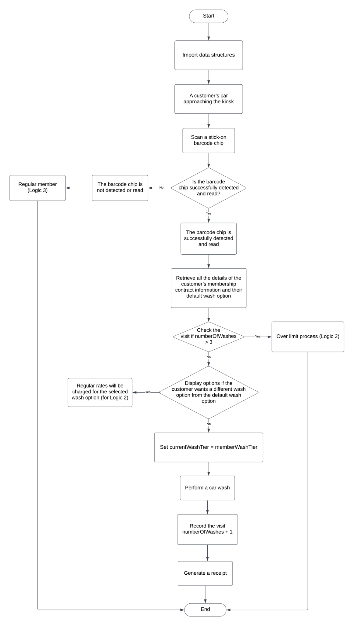

## Logic 2 Flowchart:

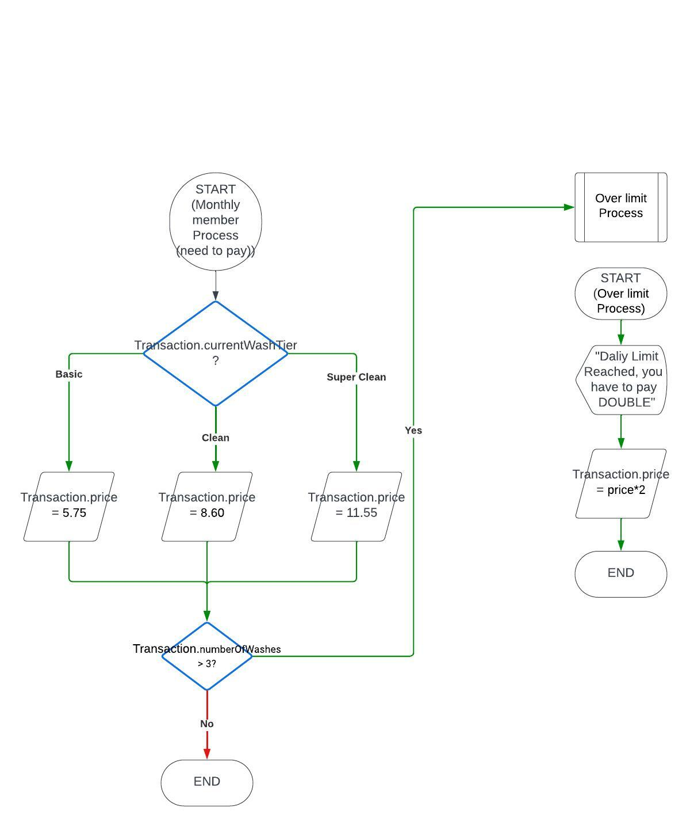

## 

## Logic 3 Flowchart:

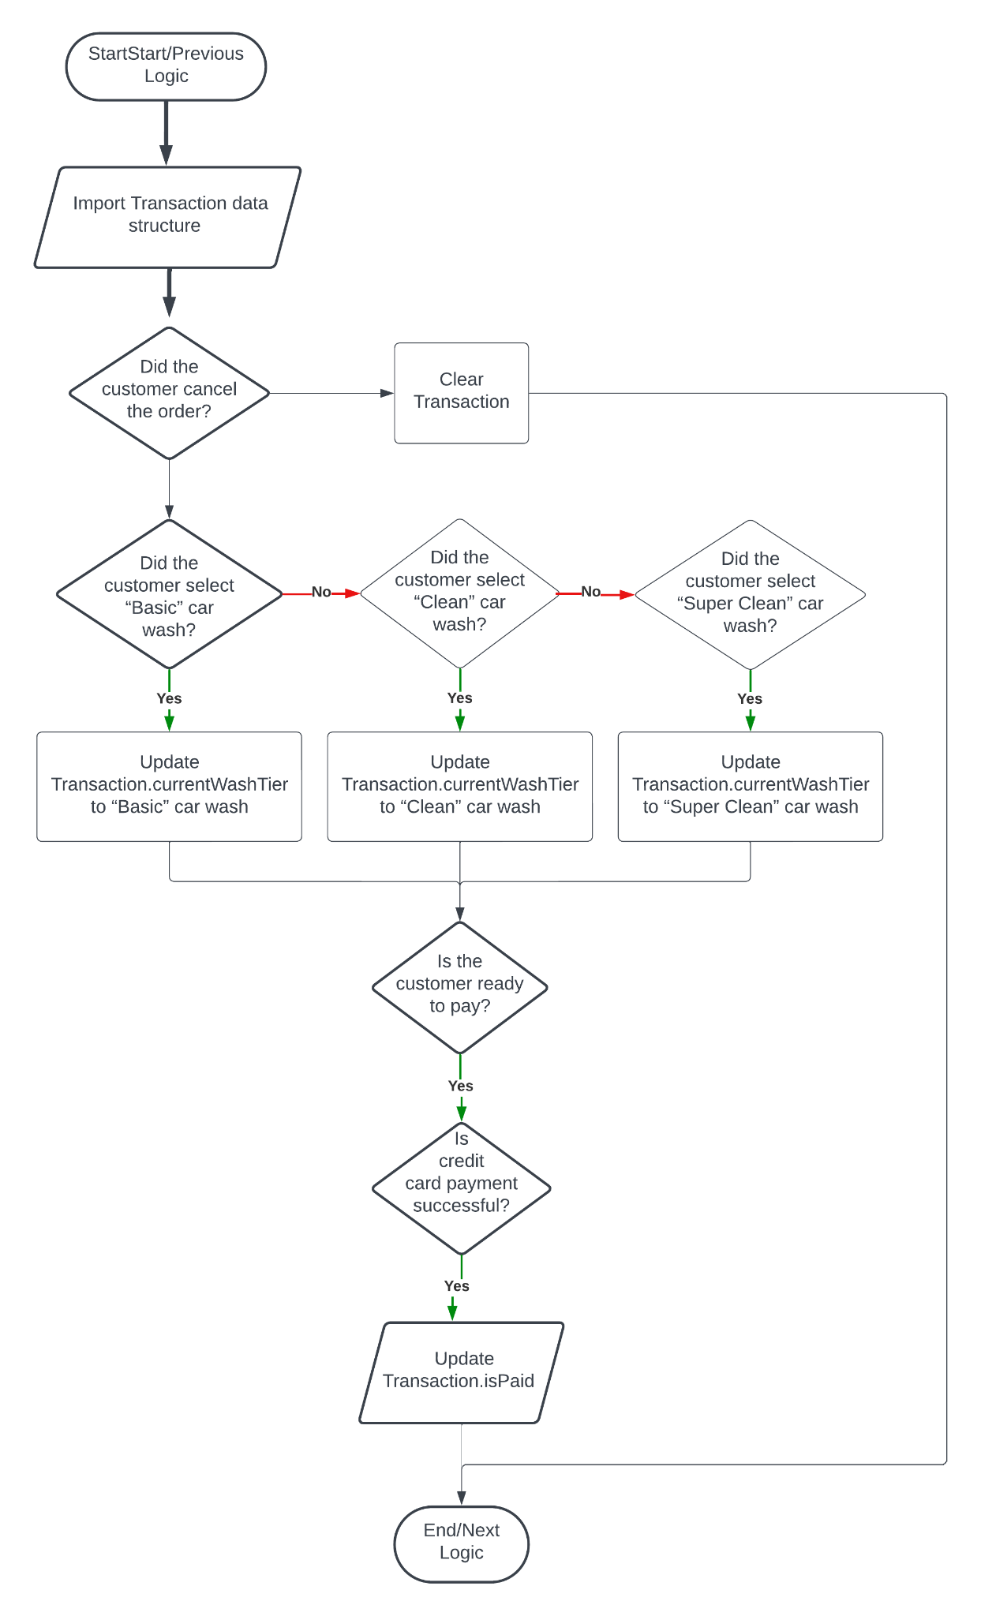

# TEST CASES

* Test Case: Monthly member with stick-on barcode chip, barcode returns True, and selects default wash option.
  + Input:
    - Customer: Monthly member with stick-on barcode chip
    - Barcode: True
    - Default wash option: Clean
  + Expected Output:
    - Receipt with customer details and selected wash option
* Test Case: Monthly member with stick-on barcode chip, barcode returns True, and overrides default wash option.
  + Input:
    - Customer: Monthly member with stick-on barcode chip
    - Barcode: True
    - Default wash option: Basic
  + Interaction:
    - Customer selects Super Clean wash option
  + Expected Output:
    - Receipt with customer details and selected wash option
* Test Case: Monthly member with stick-on barcode chip, barcode returns False.
  + Input:
    - Customer: Monthly member with stick-on barcode chip
    - Barcode: False
  + Expected Output:
    - Display Error: Barcode not detected
* Test Case: Non-monthly member with stick-on barcode chip.
  + Input:
    - Customer: Non-monthly member with stick-on barcode chip
    - Barcode: True
  + Expected Output:
    - Display: Monthly membership required for this type of service
* Test Case: User selects default wash option, wash count exceeds 3.
  + Input:
    - Wash option: Basic
    - Number of washes: 4
  + Expected Output:
    - Display: Daily Limit Reached
    - Provide Wash Option with double rates
* Test Case: User selects default wash option, wash count doesn't exceed 3.
  + Input:
    - Wash option: Clean
    - Number of washes: 2
  + Expected Output:
    - Proceed to payment interface
* Test Case: User selects a non-default wash option.
  + Input:
    - Wash option: Super Clean
  + Expected Output:
    - Proceed to payment interface
    - Test Case: Customer cancels the order.
      * Input:
        + Order canceled
      * Expected Output:
        + Transaction cleared
    - Test Case: Customer selects Basic car wash.
      * Input:
        + Wash option: Basic
      * Expected Output:
        + Transaction updated with Basic car wash
    - Test Case: Customer selects Clean car wash.
      * Input:
        + Wash option: Clean
      * Expected Output:
        + Transaction updated with Clean car wash
    - Test Case: Customer selects Super Clean car wash.
      * Input:
        + Wash option: Super Clean
      * Expected Output:
        + Transaction updated with Super Clean car wash
    - Test Case: Customer ready to pay, credit card payment successful.
      * Input:
        + Payment: Credit card
      * Expected Output:
        + Transaction marked as paid, receipt printed, gate opened
    - Test Case: Customer ready to pay, credit card payment unsuccessful.
      * Input:
        + Payment: Credit card (unsuccessful)
      * Expected Output:
        + Transaction not marked as paid, display error, no gate opening.

# FINAL DESCRIPTION

In this workshop, we collaborated to create the final pseudocode and flowchart that implement a fully automated system using a kiosk approach and decision-making based on customer data for each car wash.

We defined the main process and sub-processes handling different scenarios for monthly members who apply the prepaid wash option, monthly members who want to override the default option, monthly members who exceed the wash limit for the day, and regular customers who have to pay the selected wash option.

Further, we had to import and evaluate the transaction data structure and conditions in the sub-processes with different scenarios, then, include the three sub-processes into the main process and clear the transactions for the next visit.

This includes barcode detection, payment process, managing the wash option, recoding visits and managing limits for the sub-processes, and dealing with unexpected situation such as a customer canceling order.